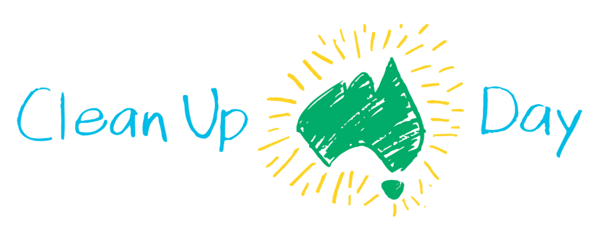
FOR IMMEDIATE DISTRIBUTION
MEDIA RELEASE
STEP UP TO CLEAN UP NOW:
CLEAN UP AUSTRALIA DAY 2021 REGISTRATIONS OFFICIALLY OPEN
01.12.20: Registrations for Australia’s largest community-based environmental event, Clean Up Australia Day (Sunday 7th March 2021), are now open at cleanup.org.au.
Local organiser, XXINSERT YOUR NAMEXX is urging residents of XXINSERT YOUR TOWN/CITYXX to get involved at XXINSERT YOUR SITEXX
The opening of registrations comes as COVID-19 restrictions that have significantly impacted local environments are easing. There has never been a better time to tackle the surge* in single-use disposable items, such as takeaway coffee cups, food packaging, masks and sanitised wipes; all of which have polluted our local parks, bushland, streets, waterways and beaches.
Research reveals* more than 1 in 3 (34%) Australian households self-identified as producing more packaging waste during lockdown periods compared to previous years, and more than 1 in 2 (55%) reported they are now more concerned about product packaging waste than they were in 2019.
Clean Up Australia Chairman, Pip Kiernan, says now is the time for all Australians to Step Up to Clean Up, to help protect and conserve local environments.
“This year has seen disruption to our lives, not least of all to our local environments which have been impacted by increased uptake of single-use, disposable items” said Ms Kiernan.
“We know Australians everywhere are itching to get involved and now is their chance to officially register interest for the next Clean Up Australia Day. Indeed, it’s never been more important to get involved and make a real difference.
“Whether you are a first time volunteer looking for a more eco-conscious New Year’s resolution, or a more seasoned Clean Up Champion looking to get prepared early ahead of next year, now is the time for you to register your involvement.
“By planning ahead and signing up to a Clean Up event, you are making a pledge to help conserve the environment for the long-term future, and taking an important action by stepping up for your community,” added Ms Kiernan.
In response to COVID-19, additional conditions will be put in place to ensure the health and safety of Clean Up volunteers, including set limits to volunteer numbers per event and Clean Up kits will now include QR codes for registration on the day and hand sanitiser, plus bags and gloves for every volunteer.
The announcement of early-bird registrations follows heightened calls this year for more sustainable pathways for the nation, which include increased attention on 100% reusable, recyclable or compostable household packaging within the next decade.
“Stepping Up to Clean Up goes well beyond one day. It’s an ongoing commitment to protecting our environment and looking for ways to help live more sustainably 365 days a year,” said Ms Kiernan.
“Most recently, the 2025 National Packaging Targets** set a clear path and open ambition for all Australians to choose a sustainable pathway for our future, which included targets for 100% reusable, recyclable or compostable packaging, so the time to get involved is now - for both Clean Up Australia Day 2021 and well beyond,” concluded Ms Kiernan.
If you can’t join a Clean Up, Ms Kiernan urges you to make a donation to Clean Up Australia. 100% of funds raised through donations are allocated to the provision of educational resources and clean up materials provided free of charge to community, school and youth groups across the nation, all year round.
For other ways to get involved, eco-conscious Australians can now get in on the Clean Up action by shopping their Buy Recycled Collections which showcase products and packaging made from recycled content, extending the life of resources we have already used and reducing the need to extract new ones from our precious planet.
To register your Clean Up, sign up to a Clean Up or donate, please visit cleanup.org.au
Clean Up Australia Day – Sunday 7 March
Business Clean Up Day – Tuesday 2 March
Schools Clean Up Day – Friday 5 March
- ENDS -
* Quantum Market Research, Pact Group Community Attitudes to Waste and Recycling Report, July 2020
** Our Packaging Future: A Collective Impact Framework to achieve the 2025 national packaging targets. April 2020
Image assets and Clean Up Australia materials are available at
cleanupaustraliaday.org.au/resources/media
MEDIA CONTACTS:
XXINSERT YOUR NAME AND CONTACT DETAILSXX

Tags and information:
Tag: @cleanupaustralia
Hashtags: #CleanUpAustralia #CleanUpAustraliaDay #StepUptoCleanUp
URL: cleanup.org.au

About Clean Up Australia
Founded by Ian Kiernan, AO, Clean Up Australia is one of the country’s most recognised and trusted environmental organisations, inspiring and empowering communities to clean up, fix up and conserve our environment. More than 18.3 million Australians have participated in a Clean Up activity over the past 30 years and over that time 36 million hours of volunteer time have been donated to Clean Up activities benefiting our environment.
Over the past three decades, Clean Up Australia has evolved into an organisation that works with community, government and businesses to provide practical solutions to help Australians all live more sustainably every day of the year. Today the organisation’s focus is as much on preventing rubbish entering our environment as it is removing what has already accumulated.

